Terraform challenge-01

Write a code using Terraform that deploys and achieves the following:-
- Create an EC2 Instance on AWS Cloud using the below-mentioned ubuntu AMI and instance_type. Or, (You can use of your choice as well) ami = "ami-0461b1436c9b3c1a3" instance_type = "t2.micro"
- Install a web server on the same EC2 Instance. The web server should listen on port 8080.
- Create a Docker-compose file for the project:https://github.com/betawins/cricbuzz-docker-hello-world.gitand point it to port 8000.
- Make the web server point to the above service so that 8080 returns the response from the Docker service.
- Configure to Save the Logs in the location /var/log/cb.log
- Write the Log rotate configuration for the above file

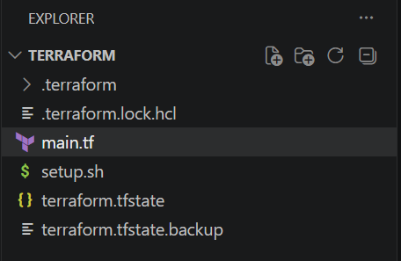

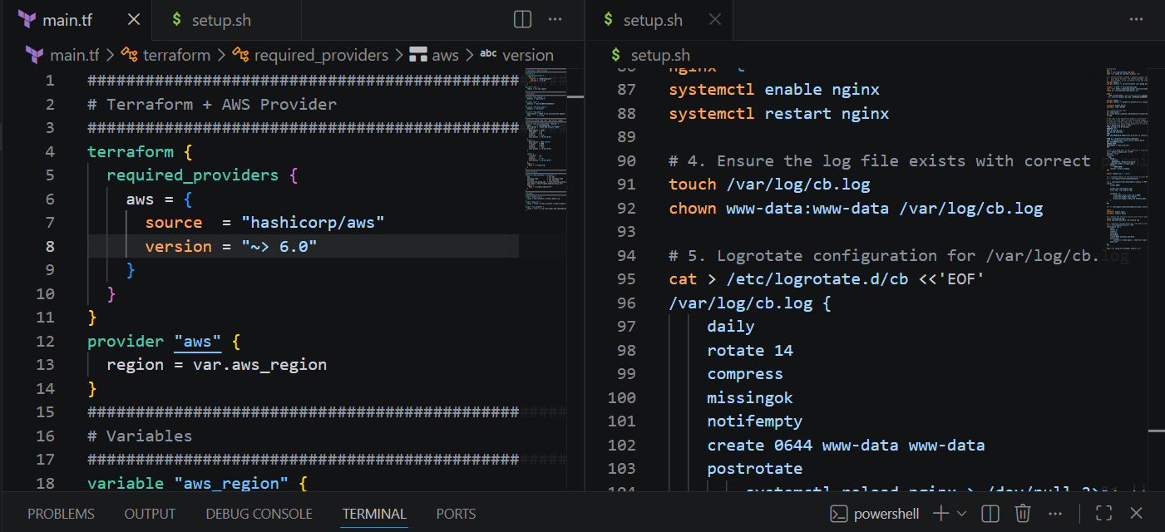
Main.tf:
###############################################################################
# Terraform + AWS Provider
###############################################################################
terraform {
required_providers {
aws = {
source = "hashicorp/aws"
version = "~> 6.0"
}
}
}
provider "aws" {
region = var.aws_region
}
###############################################################################
# Variables
###############################################################################
variable "aws_region" {
default = "ap-south-1"
}
variable "ami" {
default = "ami-01a00762f46d584a1"
}
variable "instance_type" {
default = "t3.micro"
}
variable "key_name" {
description = "Name of an existing EC2 KeyPair to SSH into the instance"
type = string
}
###############################################################################
# Security Group: SSH (22), Web server (8080)
###############################################################################
resource "aws_security_group" "web_sg" {
name = "cricbuzz-sg"
description = "Allow SSH and port 8080"
ingress {
description = "SSH"
from_port = 22
to_port = 22
protocol = "tcp"
cidr_blocks = ["0.0.0.0/0"]
}
ingress {
description = "Web server"
from_port = 8080
to_port = 8080
protocol = "tcp"
cidr_blocks = ["0.0.0.0/0"]
}

egress {
from_port = 0
to_port = 0
protocol = "-1"
cidr_blocks = ["0.0.0.0/0"]
}
tags = {
Name = "cricbuzz-sg"
}
}
###############################################################################
# EC2 Instance
###############################################################################
resource "aws_instance" "cricbuzz" {
ami = var.ami
instance_type = var.instance_type
key_name = var.key_name
vpc_security_group_ids = [aws_security_group.web_sg.id]
user_data = file("${path.module}/setup.sh")
tags = {
Name = "cricbuzz-web-server"
}
}
###############################################################################
# Outputs
###############################################################################
output "public_ip" {
value = aws_instance.cricbuzz.public_ip
}
output "app_url" {
value = "http://${aws_instance.cricbuzz.public_ip}:8080"
}
output "ssh_command" {
value = "ssh -i ${var.key_name}.pem ubuntu@${aws_instance.cricbuzz.public_ip}"
}
Setup.sh:

#!/bin/bash
set -e
exec > /var/log/cb-setup.log 2>&1
echo "=== setup.sh started: $(date) ==="

# 1. Install Docker (engine + compose plugin) from Docker's official repo,
# plus Nginx and Git. The Ubuntu-packaged 'docker-compose' is unreliable
# across AMIs, so we use Docker's own apt repo for a consistent install.
apt-get update -y
apt-get install -y ca-certificates curl gnupg git nginx

install -m 0755 -d /etc/apt/keyrings
curl -fsSL https://download.docker.com/linux/ubuntu/gpg -o /etc/apt/keyrings/docker.asc
chmod a+r /etc/apt/keyrings/docker.asc

echo \
"deb [arch=$(dpkg --print-architecture) signed-by=/etc/apt/keyrings/docker.asc] https://download.docker.com/linux/ubuntu \
$(. /etc/os-release && echo "$VERSION_CODENAME") stable" | tee /etc/apt/sources.list.d/docker.list > /dev/null

apt-get update -y
apt-get install -y docker-ce docker-ce-cli containerd.io docker-buildx-plugin docker-compose-plugin

systemctl enable docker
systemctl start docker

# 2. Clone the app repo
cd /home/ubuntu
git clone https://github.com/betawins/cricbuzz-docker-hello-world.git app
cd app

# The repo's own Dockerfile expects a pre-built 'hello_world' binary to already
# exist (it just COPYs it into a scratch image) and the app listens on 8080
# internally. Rather than rely on the repo's Makefile, we build the Go binary
# ourselves in a multi-stage Dockerfile so the build is self-contained.
cat > Dockerfile.build <<'EOF'
FROM golang:1.22 AS builder
WORKDIR /src
COPY go.mod go.sum ./
RUN go mod download
COPY . .
RUN CGO_ENABLED=0 GOOS=linux go build -o /hello_world .

FROM gcr.io/distroless/static-debian12
COPY --from=builder /hello_world /hello_world
ENV GIN_MODE=release
EXPOSE 8080
ENTRYPOINT ["/hello_world"]
EOF

# Host port 8000 maps to the container's internal port 8080 (where the app listens)
cat > docker-compose.yml <<'EOF'
version: "3.8"
services:
app:
build:
context: .
dockerfile: Dockerfile.build
container_name: cricbuzz-app
ports:
- "8000:8080"
restart: unless-stopped
EOF

docker compose up -d --build

# 3. Configure Nginx as the web server on port 8080, proxying to port 8000
rm -f /etc/nginx/sites-enabled/default

cat > /etc/nginx/sites-available/cricbuzz <<'EOF'
server {
listen 8080;

access_log /var/log/cb.log;
error_log /var/log/cb.log;

location / {
proxy_pass http://127.0.0.1:8000;
proxy_set_header Host $host;
proxy_set_header X-Real-IP $remote_addr;
}
}
EOF

ln -sf /etc/nginx/sites-available/cricbuzz /etc/nginx/sites-enabled/cricbuzz

nginx -t
systemctl enable nginx
systemctl restart nginx

# 4. Ensure the log file exists with correct permissions
touch /var/log/cb.log
chown www-data:www-data /var/log/cb.log

# 5. Logrotate configuration for /var/log/cb.log
cat > /etc/logrotate.d/cb <<'EOF'
/var/log/cb.log {
daily
rotate 14
compress
missingok
notifempty
create 0644 www-data www-data
postrotate
systemctl reload nginx > /dev/null 2>&1 || true
endscript
}
EOF

echo "=== setup.sh finished: $(date) ==="
terraform init:
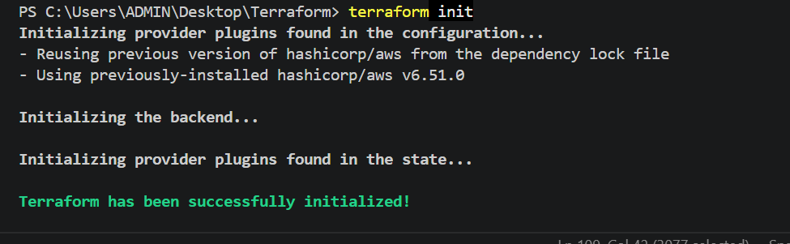
Terraform plan:
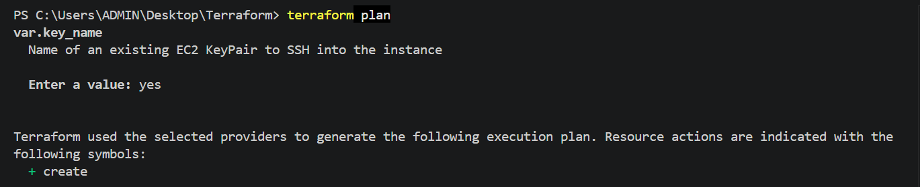

Terraform apply:
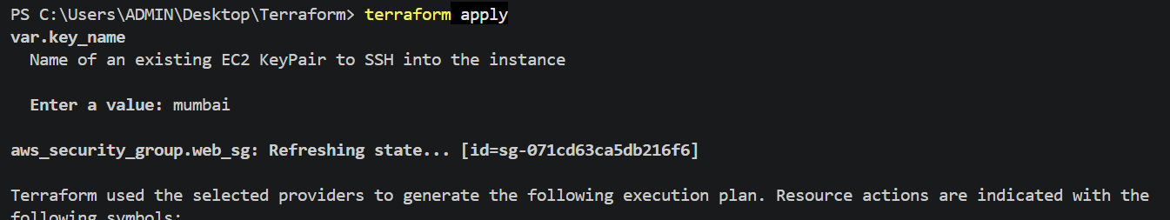
Output:
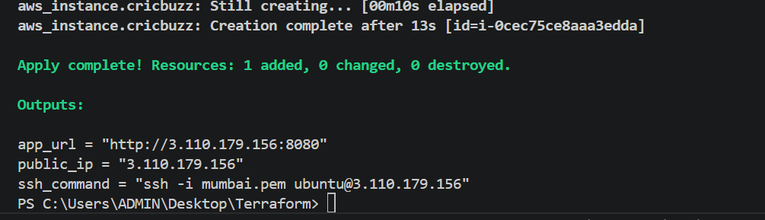
See if the application is working:
In the browser:
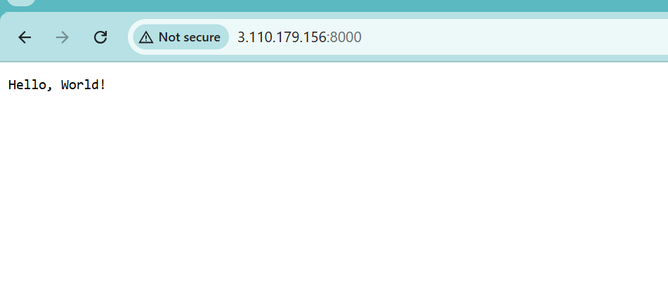

Configure to Save the Logs in the location /var/log/cb.log
Write the Log rotate configuration for the above file
